**1. INTRODUCTION**

Today’s industries are increasingly demanding process automation in all sectors. Automation results into better quality, increased production an reduced costs. The variable speed drives, which can control the speed of AC/DC motors, are indispensable controlling elements in automation systems. Depending on the applications, some of them are fixed speed and some of the variable speed drives.

The variable speed drives, till a couple of decades back, had various limitations, such as poor efficiencies, larger space, lower speeds, etc., However, the advent power electronic devices such as power MOSFETs, IGBTs etc., and also with the introduction of micro -controllers with many features on the same silicon wafer, transformed the scene completely and today we have variable speed drive systems which are not only in the smaller in size but also very efficient, highly reliable and meeting all the stringent demands of various industries of modern era.

Direct currents (DC) motors have been used in variable speed drives for a long time. The versatile characteristics of dc motors can provide high starting torques which is required for traction drives. Control over a wide speed range, both below and above the rated speed can be very easily achieved. The methods of speed control are simpler and less expensive than those of alternating current motors.

There are different techniques available for the speed control of DC motors. The phase control method is widely adopted, but has certain limitations mainly it generates harmonics on the power line and it also has got p .f when operated lower speeds. The second method is pwm technique, which has got better advantages over the phase control.

In the proposed project, a 5 H.P DC motors circuitry is designed, and developed using pulse with modulation (PWM).The pulse width modulation can be achieved in several ways. In the present project, the PWM generation is done using micro- controller.

In order to have better speed regulation, it is required to have a feedback from the motor. The feedback can be taken either by using a tachogenerator or an optical encoder or the back EMF itself can be used .In present project, we implemented the feedback by using the EMF of the armature as the feedback signal.

The project proposed is a real time working project, and this can be further improvised by using the other safety features, such as field current, air gap magnetic flux, armature current, etc.,

**2. DC MOTOR**

**2.1 INTRODUCTION TO SPEED CONTROL**

Speed control means intentional change of drive speed to a value required for performing the specific work process. This concept of speed control or adjustment should not be taken to include the natural change in speed which occurs due to change in the load on the shaft.

Any given piece of industrial equipment may have its speed change or Adjusted mechanically by means of stepped pulleys, sets of change gears, variable speed friction clutch mechanism and other mechanical devices. Historically it is proved to be the first step in transition from nonadjustable speed to adjustable speed drive. The electrical speed control has many economical as well as engineering advantages over mechanical speed control.

The nature of the speed control requirement for an industrial drive depends upon its type. Some drives may require continues variation of speed for the whole of the range from zero to full speed or over a portion of this range , while the others may require two or more fixed speeds

**2.2 CLASSIFICATION OF DC MOTORS**

DC motors are classified into three types depending upon the way their field windings are excited. Field windings connections for the three types Of DC motors have been shown in figures.

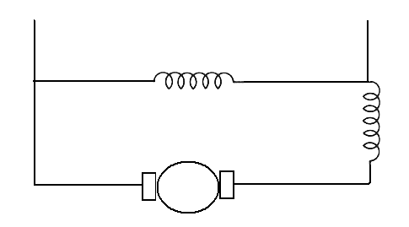

**Saturating field**

**V**

**M**

(a). DC Shunt Motor

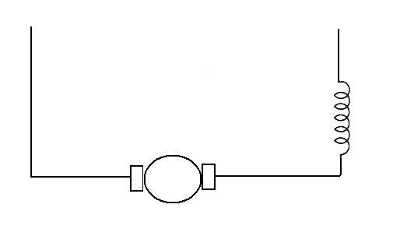

**M**

**V**

**Series field**

(b). DC Series Motor

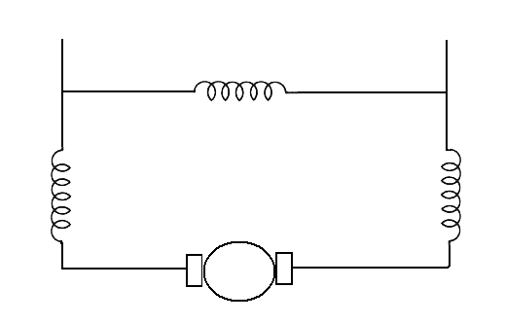

**Series field**

**M**

**V**

**Shunt field**

(c). DC Compound Motor

Fig.2.1: Classifications of DC Motors

**2.3 SPEED CONTROL OF DC MOTORS**

The DC motors are in general much more adaptable speed drives than AC motors which are associated with a constant speed rotating field. Indeedone of the primary reasons for the strong competitive position of DC motors in modern industrial drives is the wide range of specified afforded we know the equation

N= K ($E_{b}/$ ϕ) =K (V-Ia Ra / ϕ)

Where V=supply voltage (volts)

Ia=armature current (amps)

Ra=armature resistance (ohms)

Φ=flux per pole(Weber)

$$E_{b}=backemf\left(volts\right)$$

This equation gives two methods of effective speed changes.i.e.

1. The variation of field excitation, if this causes in the flux per pole Φ and is known as the field control.
2. The variation of terminal voltage (V).this method is known as armature control.

**2.4 SPEED CONTROL OF SHUNT MOTOR**

**2.4.1 FLUX CONTROL METHOD**

It is known that Nα1/ Φ by decreasing the flux, the can be increased and vice versa. Hence, name flux or field controls method.

The flux of DC motor can be changed by changing $I_{sh}$ with help of a shunt field rheostat. Since $I_{sh}$ in relatively small, shunt field rheostat has to carry only a small,so that rheostat is small in size. This method therefore very efficient in non-inter polar machines the speed can be increased by this method in the ratio 2:1 any further weakening of flux Φ adversely affect the communication

And hence puts a limit to the maximum speed obtainable with this method in machines fitted with interlopes in ratio of maximum to minimum speeds of 6:1 is fairly common.

The connection diagram for this type of speed control is shown in figure below.

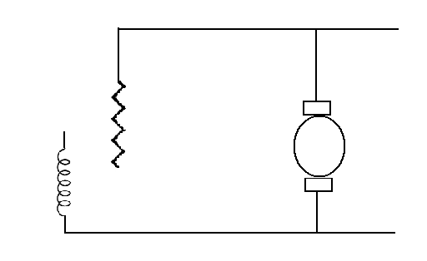

V

**Field rheostat**

Fig.2.2: Flux Control Method

**2.4.2 ARMATURE OR RHEOSTAT CONTROL METHOD**

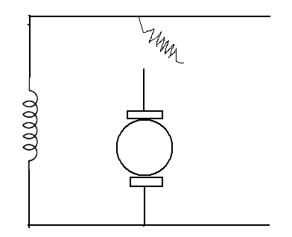

**Field**

V

Ia

**Controller**

**Resistance**

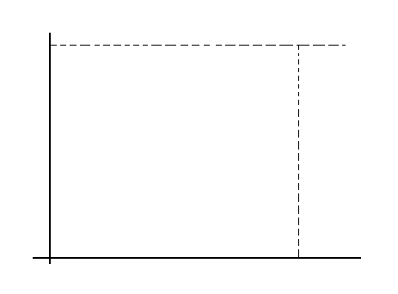

Resistance in

armature

Speed, N

Armature current, Ia

Armature in

Fig. 2.3: Speed Vs Armature current characterstics

This method is used when speeds below the no load speed are required. As the supply voltage is normally constant, the voltage across the armature is varied by inserting a variable rheostat or controller resistance in series with the armature circuit as shown in fig. as controller resistance is increased, potential difference across the armature is decreased, thereby decreasing the armature speed. For a load of constant torque, speed is approximately proportional to the potential difference.

Across the armature current characteristics in fig. in seen that greater the resistance

In the armature circuit, greater is the fall in speed

Let

Ia1=Armature current in the first case

Ia2=Armature current in the second case

N1, N2=corresponding speeds

V=Supply voltage

Then N1 $α$ (v-Ia1Ra )αEb1

Let some controller resistance of value R be added to the armature circuit resistance so that its value becomes

(R+Ra)=Rt

Then

N2 α(V-Ia2 Rt) α Eb2

N2/N1=Eb2/Eb1

Considering no load speed, we have

N/N0 (I-(IaRt)/(V-Ia0 Ra)

Neglecting IaoRa w.r.t.toV, we get

N=No (I-(IaRt)/V

**Speed,N**

**No**

**Ia**

**Im**

It is seen that for a given resistance Rt the speed is a linear function of armature current Ia as shown in fig.

The load current for which the speed would be zero is found by putting N=0 in above relation

0=N0((I-IaRt)/V) Or Ia=V/Rt

This maximum current and is known as stalling current. This method is very wasteful, expensive and unsuitable for rapidly changing loads because for a given value of Rt, speed will change with load. A more stable operation can be obtained by using a diverter across the armature in addition to armature control resistance.

Now, the changes in armature current will not be so effective in changing the potential difference across the armature. The connection diagram for this type of speed control arrangement

**2.5 MOTOR APPLICATIONS**

DC motor possesses excellent torque speed characteristics and offer a wide range of speed control. Though efforts are being made to obtain wide range speed control with ac motors, yet the versatility and flexibility of a dc motors can’t be matched by a ac motors.

In view of this, the demand for dc motors would continue undiminished even in figure. A brief discussion regarding the dc motor applications is given below.

* **SHUNT MOTORS**

For a given field current in a shunt motor, the speed drop from no load to full load is invariably less than 6% to 8%. In view of this, the shunt motor is termed a constant speed motor. Therefore for constant speed drives in industry, dc shunt motors can be employing. But this motor can’t complete with constant speed squirrel cage induction motor, because the latter cheaper, rugged and requires less maintenance.

When constant speed service at low speeds is required, the comparison is usually between synchronous motors and dc shunt motors. It is because the construction of high performance poly phase induction motor with large number of poles is difficult. However, for adjustable speed service at low operating speed, DC shunt motor is a preferred choice

When the driven load requires a wide range of speed control (both below base speed and above base speed), a dc shunt motor is employed, e.g. .in latches etc.

* **SERIES MOTORS**

The outstanding feature of series motor is the automatic decrease in speed as soon as increased load torque is required. The decreasing speed with increase in load torque or vice versa has only a marginal effect on the power taken by the series motor.

* Since a series motor can withstand severe starting duties and can furnish high starting torques , it is best suited for driving hoists, trains , excavators ,cranes, etc. wound motor induction motors compete favorably with series motor’s ,but the choice is governed by the economics . However for traction purposes, series motor is the only choice. Therefore series motors are widely used in all types of electric vehicles, electric trains, streetcars, battery powered tools, automotive starter motors etc.
* Series motors can be used to drive permanently connected loads, such as fan load, because their torque requirement increases with the square of the speed
* In order to avoid the pollution in big cities, now battery driven automobiles are being introduced on a large scale.
* **COMPOUND MOTORS**

A compound motor with a strong series field has its characteristics approaching that of a series motor. Therefore such type of compound motors are used for loads requiring heavy starting torque which are likely to be reduced to zero

A compound motor with weak series field has its characteristics approaching that of a shunt motor. Weak series field causes more drooping speed torque characteristics than with an ordinary shunt motors. Such compound motors with steeper characteristics, are used where load fluctuates between wide limits intermittently.

**3. OPERATION OF DC MOTOR SPEED CONTROL**

We use DC fans in many systems in our day to day life. For example, CPU fans, fume extinguishers and many more appliances which we make use of are operated by DC. Most of the times we will have a need to adjust the speed of the motors to our requirement. Although some systems have an automatic adjustment system for fan speed, not all systems possess this functionality. So, we will have to adjust the speed of our fan ourselves occasionally. To adjust the speed of our fan manually, there are multiple ways to do that. We can adjust the speed by using a resistance in series with the motor.

.



Fig.3.1: Circuit Diagram of DC Motor Speed Control using PWM

This is the simplest of all ways but it is not usually preferred because if we want to use any devices like microcontrollers or any other digital equipment for automating our DC fan speed, then this method will not work in general. A more efficient way to proceed is by using pulse width modulation technique to manage the speed of our DC motor. One of the best things about this circuit is that we can make it work as an astable multivibrator with little hardware and by little cost which can save both the cost involved in making it as well as the space on the printed circuit board is saved. if we want a sophisticated pulse width modulator which works more accurately and which can have more adjusting capabilities, then it is better to use a microcontroller based pulse width modulator than the one which we are using now. However, the circuit or the application for which we are using a pulse width modulator is not so sensitive and hence does not demand so much of accuracy. In such a case, the circuit which we are using with a bare IC 555 is better as it saves our monetary as well as space resources in building the circuit. The duty cycle of the circuit can be changed by changing the resistance between pin-7 and pin-6. If we increase the duty cycle, the speed of the motor increases and if we decrease the duty cycle, the speed of the motor decreases.

**3.1 PIN DIAGRAM**



Fig:3.2: Pin Diagram of 555 Timer

In this circuit, the DC motor is operated by a 555 integrated circuit. The IC 555 in this circuit is being operated in astable mode. In this mode, the circuit can be used as a pulse width modulator with a few small adjustments to the circuit. The frequency of operation of the circuit is provided by the passive parameters of resistances and capacitances attached to it. The resistance between pin-7 and pin-8, the resistance between pin-6 and pin-7 and the capacitance between pin-2 and the ground govern the frequency of operation and duty cycle of the IC 555 in astable mode.

﻿**3.2 OPERATION OF VARIABLE RESISTANCE**

This is one of the most effective circuits used to manage the speed of DC motor with the help of pulse width modulation. In this circuit, the DC motor is operated by a 555 integrated circuit. The IC 555 in this circuit is being operated in astable mode. In this mode, the circuit can be used as a pulse width modulator with a few small adjustments to the circuit. In this circuit, the DC motor is operated by a 555 integrated circuit. The IC 555 in this circuit is being operated in astable mode. In this mode, the circuit can be used as a pulse width modulator with a few small adjustments to the circuit. The frequency of operation of the circuit is provided by the passive parameters of resistances and capacitances attached to it.

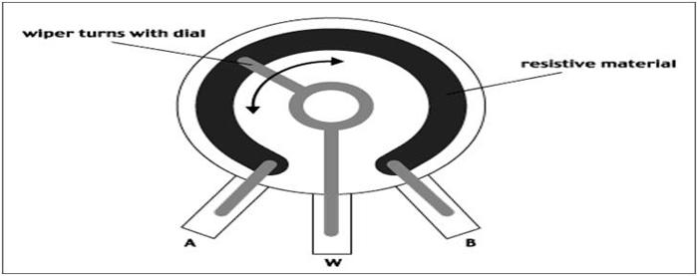

Fig.3.3: Operation of Variable Resistance

The resistance between pin-7 and pin-8, the resistance between pin-6 and pin-7 and the capacitance between pin-2 and the ground govern the frequency of operation and duty cycle of the ic 555 in astable mode. The duty cycle is governed by the resistor which is in between pin-6 and pin-7 of the IC 555 timer. So, by taking advantage of the circuits working, we can change the 555 astable multivibrator into a pulse width modulator by using a variable resistor instead of a constant resistor in between pin-6 and pin-7.The duty cycle of the circuit can be changed by changing the resistance between pin-7 and pin-6. If we increase the duty cycle, the speed of the motor increases and if we decrease the duty cycle, the speed of the motor decreases.

**4. SWITCHING DEVICES & PWM TECHNIQUE**

**4.1 POWER SEMICONDUCTOR DEVICES**

**Power semiconductor devices**

**3 Terminal devices**

**2 Terminal devices**

**Schotkey diode**

**PN Diode**

**IGBT**

**Thyristor**

**JFET**

**Power MOSFET**

**BJT**

Fig. 4.1: Classification of Switching Devices

Today’s power semiconductor devices are almost exclusively based on silicon material and can be classified as follows:

* + Diode
  + Thyristor or silicon-controlled rectifier (SCR)
  + Bipolar junction transistor (BJT)
  + Power MOSFET
  + **DIODE**

Power diodes provide uncontrolled rectification of power and are used in applications such as electroplating, anodizing, battery charging, welding, power supplies (dc and ac), and variable frequency drives. They are also used in feedback and the freewheeling functions of converters and snubbers. Shows the diode symbol and its volt-ampere characteristics. In the forward biased condition, the diode can be represented by a junction offset drop and a series-equivalent resistance that gives a positive slope in the V-I characteristics. The typical forward conduction drop is 1.0 V. This drop will cause conduction loss, and the device must be cooled by the appropriate heat sink to limit the junction temperature. In the reverse-biased condition, a small leakage current flows due to minority carriers, which gradually increase with voltage. If the reverse voltage exceeds a threshold value, called the breakdown voltage, the device goes through avalanche breakdown, which is when reverse current becomes large and the diode is destroyed by heating due to large power dissipation in the junction.

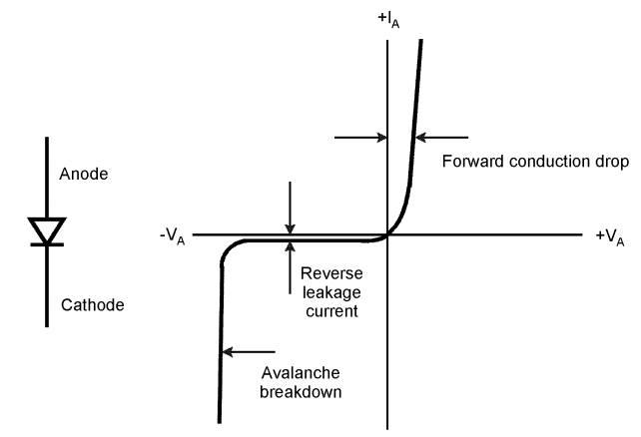

Fig.4.2: Symbol & Characteristics of Diode

* **PWM TECHNIQUE**

Pulse-width modulation (PWM) or duty-cycle variation methods are commonly used in speed control of DC motors. The duty cycle is defined as the percentage of digital ‘high’ to digital ‘low’ plus digital ‘high’ pulse-width during a PWM period.

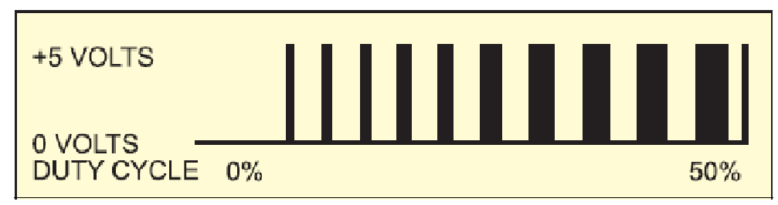

Fig.4.3: 5V Pulses With 0% Through 50% Duty Cycle

Fig shows the 5V pulses with 0% through 50% duty cycle. The average DC Voltage value for 0% duty cycle is zero; with 25% duty cycle the average value is 1.25V(25% of 5V). With 50% duty cycle the average value is 2.5V, and if the duty cycle is75%, the average voltage is 3.75V and so on. The maximum duty cycle can be 100%,which is equivalent to a DC waveform. Thus by varying the pulse-width, we can vary theaverage voltage across a DC motor and hence its speed. The average voltage is givenby the following equation:

ý = D. Ymax + (1- D) Ymin

But usually minimum equals zero so the average voltage will be:

ý = D. Ymax

The circuit of a simple speed controller for a mini DC motor, such as that used in tape recorders and toys, is shown in Fig.4.4

1. Write an assembly program to generate a PWM with afrequency of 1 kHz and a duty cycle of 50%, and watch your signal on the oscilloscope.
2. Now connect your signal to the motor driver.

The major reason for using pulse width modulation in DC motor control is to avoid the excessive heat dissipation in linear power amplifiers. The heat dissipation problem often results in large heat sinks and sometimes forced cooling.

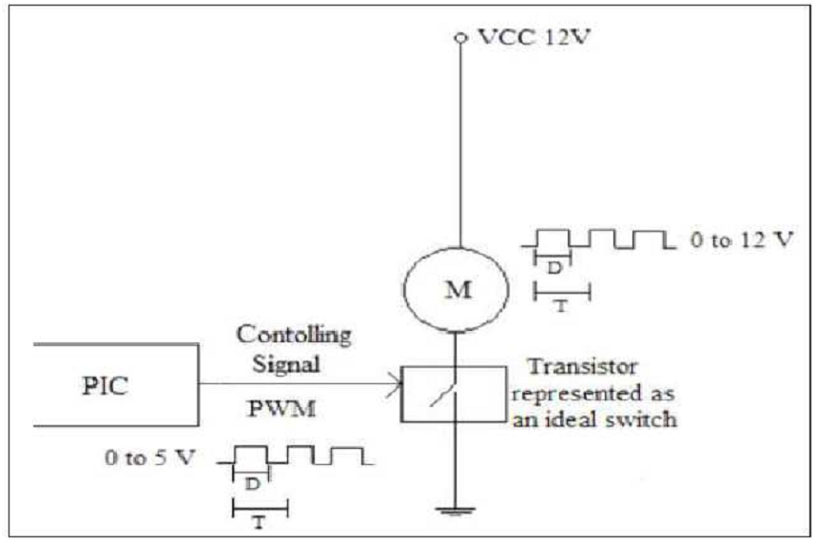

Fig.4.4: DC motor speed control using PWM method

PWM amplifiers greatly reduce this problem because of their much higher power conversion efficiency. Moreover the input signal to the PWM driver may be directly derived from any digital system without the need for any D/A converters.

The PWM power amplifier is not without disadvantages. The desired signal is not translated to a voltage amplitude but rather the time duration (or duty cycle) of a pulse. This is obviously not a linear operation. But with a few assumptions, which are usually valid in motor control, the PWM may be approximated as being linear (i.e., a pure gain).The linear model of the PWM amplifier is based on the average voltage being equal to the integral of the voltage waveform.

Thus VS * Ton = Veq * T

Where

VS = the supply voltage (+12 volts)

Ton = Pulse duration

Veq = the average or equivalent voltage seen by the motor

T = Switching period (1/f)

The recommended switching frequency is 300Hz.

The switching frequency (1/T), is determined by the motor and amplifier characteristics.

The control variable is the duty cycle which is Ton / T. The duty cycle must be recalculated at each sampling time. The voltage that the motor sees is thus Veq, which is equal to the duty cycle times the supply voltage.

**4.2 PRINCIPLE OF PULSE WIDTH MODULATION**

Pulse width modulation control works by switching the power supplied to the motor on and off very rapidly. The DC voltage is converted to a square wave signal, alternating between fully on (nearly 12v) and zero, giving the motor a series of power “kicks”.

Pulse width modulation technique (PWM) is a technique for speed control which can overcome the problem of poor starting performance of a motor. PWM for motor speed control works in a very similar way. Instead of supplying a varying voltage to a motor, it is supplied with a fixed voltage value (such as 12v) which starts it spinning immediately. The voltage is then removed and the motor ‘coasts’. By continuing this voltage on/off cycle with a varying duty cycle, the motor speed can be controlled. The wave forms in the below figure to explain the way in which this method of control operates. In each case the signal has maximum and minimum voltages of 12v and 0v.

* In wave form, the signal has a mark space ratio of 1:1.with the signal at 12v for 50% of the time, the average voltage is 6v, so the motor runs at half its maximum speed.
* In wave form, the signal has mark space ratio of 3:1.which means that the output is at 12v for 75% of the time. This clearly gives an average output voltage of 9v, so the motor runs at 3/ 4 of its maximum speed.
* In wave form, the signal has mark space ratio is 1:3, giving an output signal that is 12v for just 25% o the time. The average output voltage of this signal is just 3v, so the motor runs at 1/4 of its maximum speed.

By varying the mark space ratio of the signal over the full range, it is possible to obtain any desired average output voltage from 0v to12v .The motor will work perfectly well, provided that the frequency of the pulsed signal is set correctly, a suitable frequency being 30Hz.setting the frequency too low gives jerky operation. and setting it too high might increase the motor’s impedance.

1:1 Mark space ratio (50% duty cycle)

3:1 Mark space ratio (75% duty cycle)

1:3Mark space ratio (25%dutycycle)

Fig.4.5: Pulse Width Modulation Waveforms

**4.3 METHODS OF PWM TECHNIQUES**

The PWM signals can be generated in a number of ways. there are several methods:

* Analogue Method
* Digital Method
* Discrete IC
* On Board Micro Controller
* **Analogue method:**

A block diagram of an analogue PWM generator is

Triangle wave generator

from radio

control receiver

PWM

comparator

receiversignelto demand signal converter

Fig. 4.6: Block Diagram of An Analogue PWM Generator

The simplest way to generate a PWM signal is the intersective method, which requires only a saw tooth or a triangle wave form (easily generated using a simple oscillator) and a comparator. When the value of the reference signal is more than the modulation wave form, the PWM signal is in the high state, otherwise it is in the low state.

* **Digital Method:**

The digital method involves incrementing a counter, an comparing the counter value with a pre-loaded register value, or value set by an ADC. Thy normally us a counter that increments periodically and is reset at the end very period of the PWM. When the counter value is more than the reference value, the PWM output changes state from high to low.

* **PWM generator chips:**

There are several IC’s available which converts a DC level into a PWM output. many of these are designed for use in switch mo power supplies .unfortunately, the devices designed for switch mode power supplies not to allow the mark-space ratio to alter over the entire 0 – 100% range. many limit the maximum to 90% which is effectively limiting the power you can send to the motors. devices designed as pulse generators should allow the whole range to be used.

* **Onboard micro controller:**

A micro controller on the robot, this may be able to generate the wave form, although if you have a more than a couple of motors, this may be toomuch of load on the micro controllers resources. So if you have chosen to use an on board micro controller, then as part of you selection process, include whether it has PWM outputs .if it has this can greatly simplify the process of generating signals.

**5. CONCLUSION**

Whenever the supply is on then the motor is rotating, on that time the optical encoder senses the motor speed and the user sets the set speed and then the motor counts the speed according to that speed .on that time the any disturbance occur to the optical encoder the counter does not count any speed. Here the three switches arte there is for sets the speed and another two is increment and decrement purpose.

The DC motor speed is controlled by using power electronic converter circuit. The PWM technique is used to control the speed of dc motor the speed sensor is used to detect the speed and closed loop control systems is used for pulse circuit. The speed pulse train will be based on required input speed. This circuit is useful to operate the dc motors at required speed. The circuit response time is too low. Hence high reliability can be achieved. The designed circuit was tested for various speed inputs satisfactorily.

**6. REFERENCES**

[1]. Gopal K Dubey “Fundamentals of Electric Drives” Narosa Publishing House New

Delhi,1989.

[2]. Muhammad H. Rashid, ‘‘Power Electronics Circuits,Devices,and Applications,”

prentice Hall, 3rdedition, 2003.

[3]. Kumara MKSC, Dayananda PRD, Gunatillaka MDPR,Jayawickrama SS, “PC based

speed controlling of a dcmotor”, A fmal year report University of MoratuwaIlliniaus

USA, 2001102.

[4]. J Nicolai and T Castagnet , “A Flexible Microcontroller Based Chopper Driving a

Permanent Magnet DC Motor”, The European Power Electronics Application. 1993

[5]. A KhoeiKh.Hadidi, “MicroProcessor Based Closed-Loop Speed Control System for

DC Motor UsingPower MOSFET”, 3rd IEEE international conference on

Electronics,Circuits and Systems( 1996) vol.2,pp.1247-1250.

[6]. Peter Spasov, “Microcontroller Technology: The68HC11” Prentice Hall, 5th edition,

2004.

[7]. Pulse width modulator module (PWMM), ATmega8Ldata she

[8]. LCD interfacing, the microcontroller and embedded systems by Muhammad

AliMazidi ,Janice Gillispie Mazidi, Rolin D. Mckinlay